Rector: Revd Annabel Barber MA (annabel,barber@advancedit.org.uk 01522 721306)

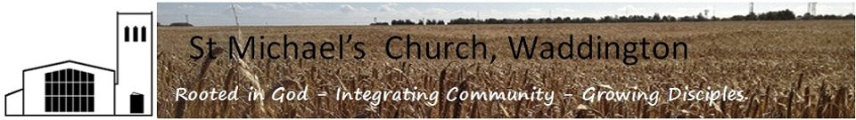
DIOCESE OF LINCOLN
POLICY STATEMENT ON THE PROTECTION AND SAFEGUARDING OF CHILDREN AND VULNERABLE ADULTS FOR USE BY PCCs
Please note:
- In relation to child protection this applies to all parishes whether or not there are any children or youth work groups in the Parishes as it assumed that some children will attend church from time to time.
- In relation to vulnerable adults the guidance applies to all Parishes.
- Acceptance of the policy/implementation should be recorded in PCC minutes.

- POLICY
St Michael’s Church, Waddington .PCC
has adopted:-
  - Protecting all God’s children edition 4 House of Bishops’ 2010 the Child protection Policy for the Church of England
  - Promoting a safe church House of Bishops’2006 the policy for safeguarding adults in the Church of England.

A copy of the full relevant policy is obtainable on the Diocese of Lincoln’s website www.lincoln.anglican.org/protection
This policy is summarised at appendix 1 (attached).

- PROTECTION OF CHILDREN AND VULNERABLE ADULTS

  - Supporting families, parents and carers. It is suggested that vulnerable adult and child protection should be seen within the context of family, parents and carer support. If one supports the family, parents or carer, one supports the vulnerable adult, child or young person. The PCC supports this approach.
  - Confidentiality The House of Bishops’ child protection policy contains ( as page 33) guidance on Confidentiality see also appendix 1 of Promoting a safe church. While respecting the need for confidentiality it is legally possible, appropriate and highly desirable to disclose relevant information to the public authorities for the sake of protecting children, young people and vulnerable adults. The PCC understands both the need for confidentiality and the requirement to disclose information to protect those who are vulnerable.
  - Insurance The House of Bishops’ Policy Protecting all God’s children page 29 gives advice about insurance for those working with children and young people. The PCC has reviewed its arrangements in the light of this advice.
  - Standards in working with children and young people. It is important that the environment in which children and youth groups meet it appropriate and safe. Further advice can be found at page 22 onwards Protecting all God’s children. The PCC has reviewed work in the light of this guidance.
  - Specific work/contact with children. The PCC has identified the following children and youth work activity where the House of Bishops’ policy should apply:-
- After School Club
- Little Angels: Tots group.
- Messy Church
- Holiday Club
- Bell Ringers
- Confirmation Group

  - Specific work/contact with Vulnerable Adults. The PCC has identified the following vulnerable adults activity where the House of Bishops’ policy should apply:-
- Pastoral visits
- First Thursday group
- Millers Road
- Welcome Wednesday
- Ministering in St Paul’s & St Michael’s Care Homes
- Home Communion

  - To support all these schemes, volunteers will be approved, supported and trained in line with the House of Bishops’ Policy. The Diocese of Lincoln will make training on safe guarding available in each deanery. Information on training can be found at the safeguarding section of the Diocese of Lincoln website. A list of all volunteers who have undergone safe-guarding training will be kept by Safe Guarding Officer (Appendix 3).
  - Posters will be displayed which feature Childline and Parentline. Copies available via the website www.lincoln.anglican.org/protection
  - What to do if you are concerned about a particular child , young person or vulnerable adult. Do not keep this to yourself. Share the concern with someone you can trust who can help you. The PCC agrees this approach. See further information at www.lincoln.anglican.org/protection
  - Monitoring arrangements. This policy, strategy, implementation and development will be reviewed annually by the PCC using the monitoring form. ( Appendix 2)

