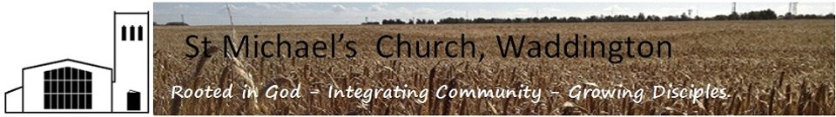
Rector: Revd Annabel Barber MA. ( annabel,barber@advancedit.org.uk 01522 721306)

Role description: Little Angels Helper

- Volunteer Role Summary
Your work will include these roles
- To assist in the planning and co-ordination of Little Angels activities for children under 5 years old, and their parents/carers in a way that meets and develops their personal, spiritual and social needs
- To exercise active pastoral concern
- To maintain a link with parents and carers
- To work in accordance with the church’s policy on safeguarding.
- To undertake any other work that has been agreed and is seen to be appropriate

- Skills, knowledge and experience required

Workers with children should have a commitment to:
- Treat them with respect.
- Recognise and respect their abilities and potential for development.
- Promote their rights to make their own decisions and choices, unless it is unsafe.
- Ensure their welfare and safety.
- The promotion of social justice, social responsibility and respect for others.
- Confidentiality, never passing on personal information, except to the person you are responsible, unless there are safeguarding issues of concern. These must always be reported.
The ability to
- Relate informally to very young people.
- Complete the church safeguarding training course
- To initiate informal conversations with young people.
- To assist with or lead through prepared Bible study material and activities with children.

- Other Requirements
- Current DBS Enhanced Disclosure that meets our minimum requirements
- Current church membership (any recognised denomination)

- Other information relevant to this job description
- St Michael’s safeguarding policy
- St Michael’s Mission statement

- Responsible to:
The Parish Priest Revd Annabel Barber (or her named representative) and through them to the Parochial Church Council

